Question 1 : Create a ranking of students based on score (highest first).

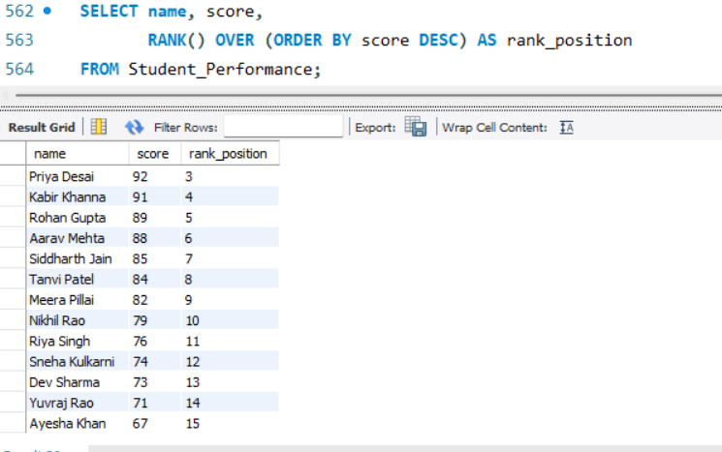
Question 2 : Show each student's score and the previous student’s score (based on score order).

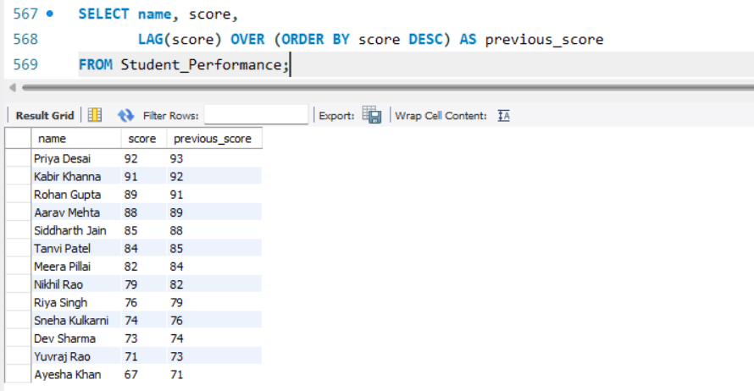

Question 3 : Convert all student names to uppercase and extract the month name from join_date.
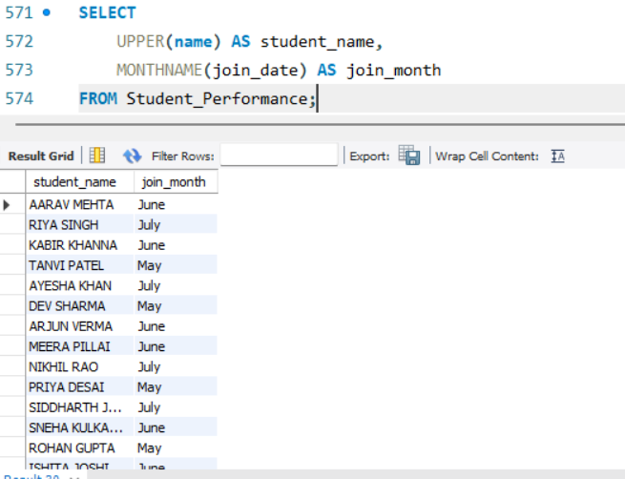

Question 4 : Show each student's name and the next student’s attendance (ordered by attendance).

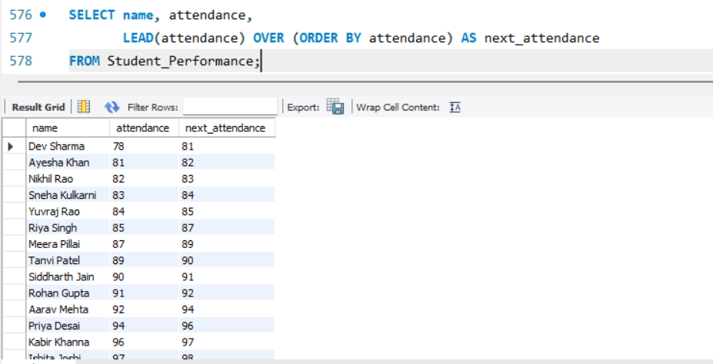

Question 5 : Assign students into 4 performance groups using NTILE().

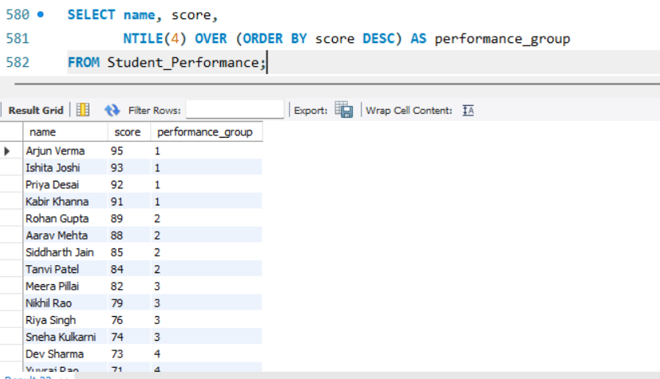
Question 6 : For each course, assign a row number based on attendance (highest first)

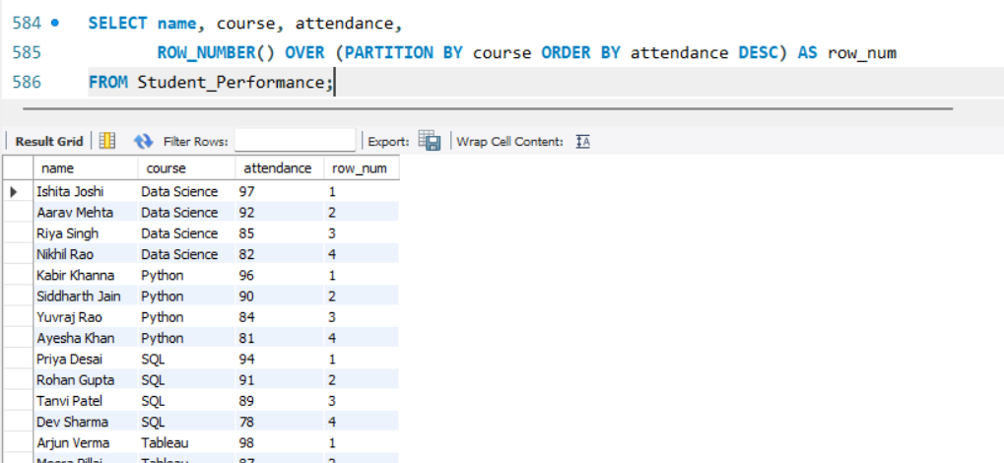

Question 7 : Calculate the number of days each student has been enrolled (from join_date to today). (Assume current date = '2025-01-01')

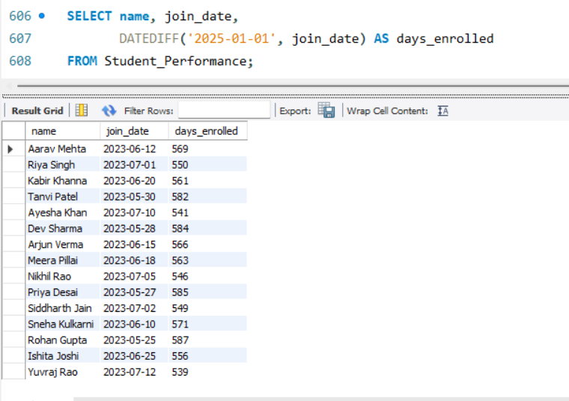

Question 8 : Format join_date as “Month Year” (e.g., “June 2023”).
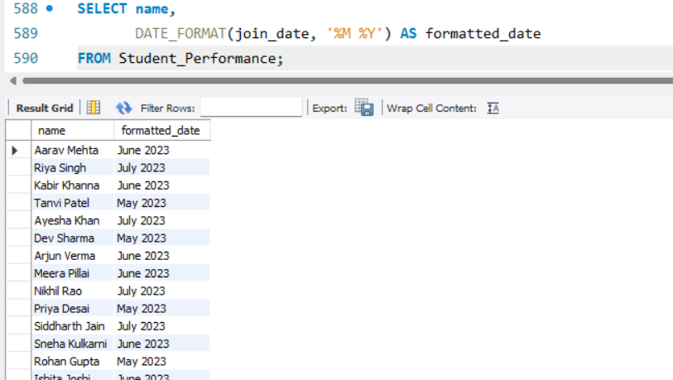

Question 9 : Replace the city ‘Mumbai’ with ‘MUM’ for display purposes.
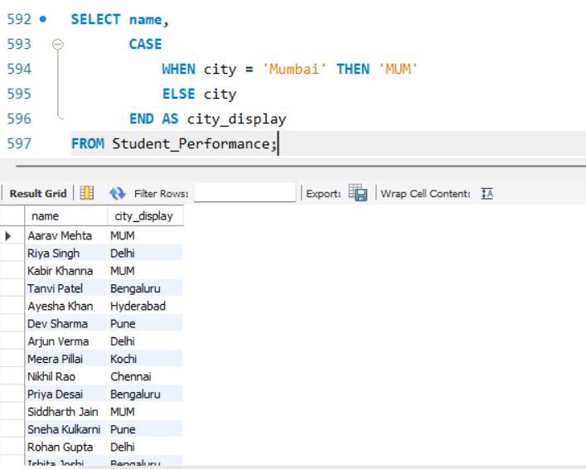

Question 10 : For each course, find the highest score using FIRST_VALUE().

